

**WEB ENGINEERING**

**ASSIGNMENT 1**

**ALPHABET LEARNING WEB APP**

**DESCRIPTION DOCUMENT**

**NAME:** HAMZA IQTADAR

**REG. NO.** 05700

**CLASS:** BESE 4-A

**DATE:** 11TH OCTOBER 2015

**INSTRUCTOR:** FAHAD AHMAD SATTI

**LAB ENGINEER:** AHSAN GUL

**Repository Link:** <https://github.com/hamzaiqtadar/HamzaIqtadar_05700_A1>

An interactive alphabet learning web application was developed in his assignment. The alphabets featured in the application were Urdu alphabets.

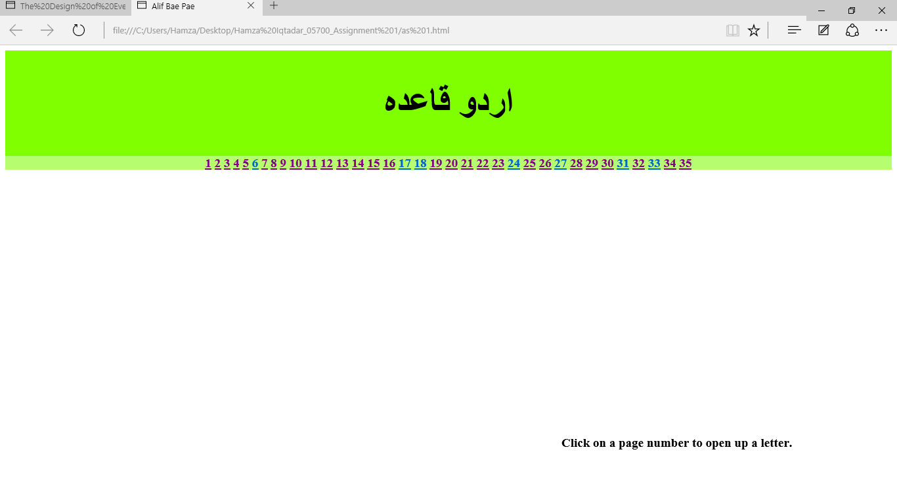

The web app provides its user with a chance to learn the Urdu alphabets. It also shows a word starting or containing the alphabet and contains a picture corresponding to the word.

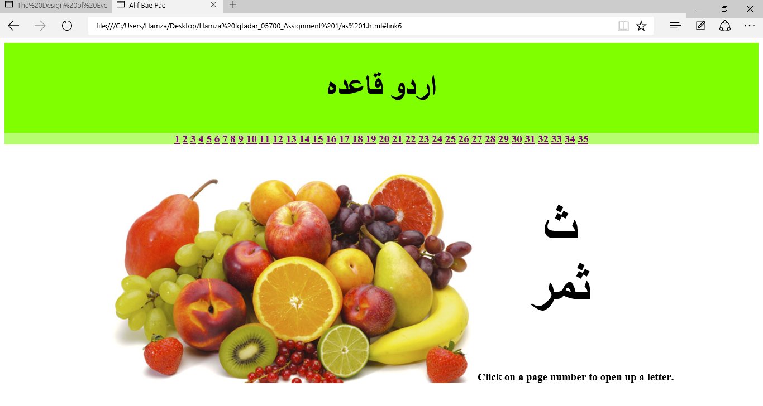

The web app was constructed using only HTML5 and CSS3. Urdu was written in the document using UTF-8 in the Meta charset tag in the head. An individual div was made for the heading and a background color was given to the div, along with a heading being inserted.

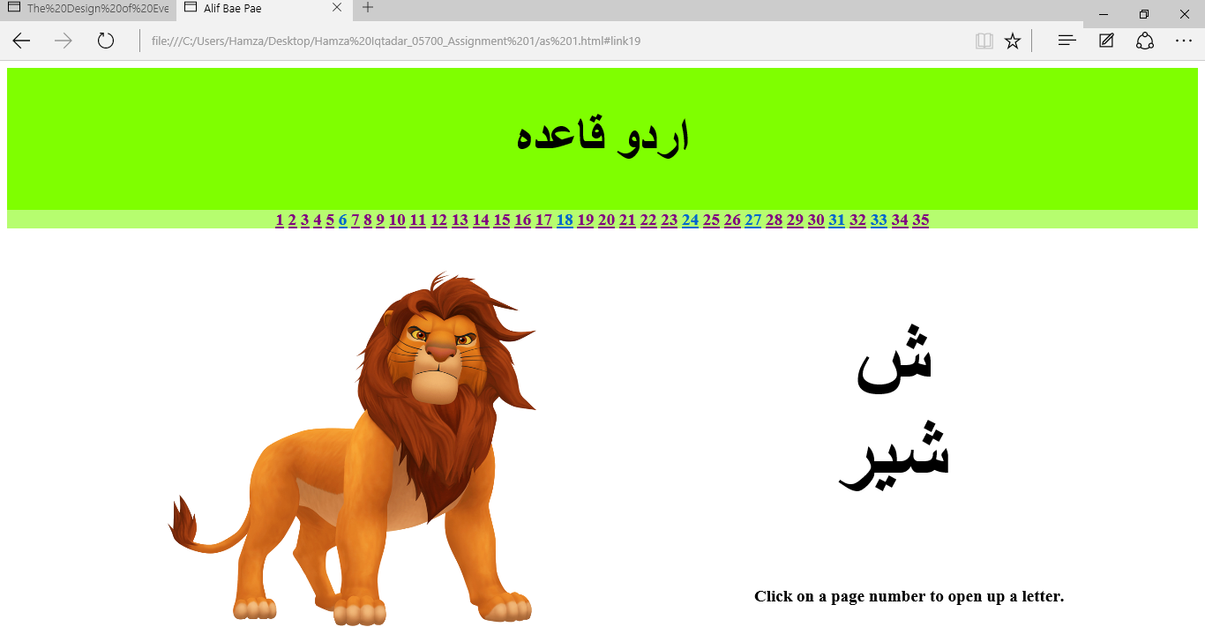

Links were made for all the alphabets inside separate anchor tags. Clicking on the link would display the corresponding alphabet, word and image. Images were added for the alphabets using the <img> tag. However, only 24 images could be added, therefore the rest had to be drawn using CSS.

**References:** [**https://css-tricks.com/examples/ShapesOfCSS/**](https://css-tricks.com/examples/ShapesOfCSS/)